2014 Marsh Grown Pre-Order Spring Plant Sale 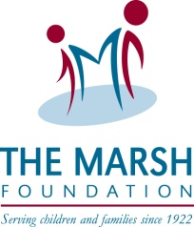
Proven Winners: Supertunia  Sun | Color: | Quantity:  1qt.($3.50) | 10” hanging basket ($17) | Cost:
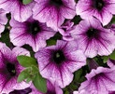 | Bordeaux  (deep purple)
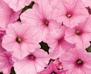 | Bubble Gum  (pink)
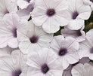 | Mini Silver  (white w/purple)

1 quart annual size @ $3.50 each |  | Quantity: | Cost:
Laguna™ Sky Blue  Lobelia erinus  Annual  Part Sun to Sun 8 – 10 | 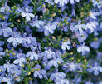
Diamond Frost®  Euphorbia graminea  Annual  Part Sun to Sun 12-18 | 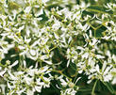
Temari® Red  Verbena hybrid  Annual  Sun 5 - 7 | 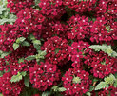

Goldilocks Rocks®  Bidens ferulifolia  Annual  Sun 12 - 14 | 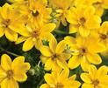

1 quart perrenial size @$5.00 each |  | Quantity: | Cost:
Dolce® Blackberry Ice  Coral Bells Heuchera hybrid  Perennial  Sun or Shade 8 – 12  Yellow Flowers | 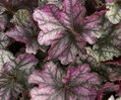
Dolce® Creme Brulee Coral Bells Heuchera  Perennial  Sun or Shade 8 – 16  Pink Flowers | 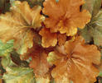
Dolce® Cinnamon Curls Coral Bells Heuchera hybrid  Perennial  Part Sun to Sun 8 – 12  White Flower | 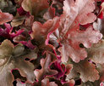
Dolce® Key Lime Pie Coral Bells Heuchera  Perennial  Part Shade to Shade 8 - 16  Pink Flower | 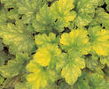
TOTAL COST:
Name: __________________________ Weekend Phone#:____________________
Email: ________________________________________________________
Please place your order by April 18th to sgrone@marshfoundation.org or call 419-605-2512. Pick-up @ Spring Plant Sale: Saturday, May 10th 10-2. We will also have additional plants & vegetables for door sales. All proceeds go to Marsh Grown Garden Program. Thank you!

